OPERATING SYSTEMS

MODULE 4

Memory Management: Concept of address spaces, Swapping, Contiguous memory allocation, fixed and variable partitions, Segmentation, Paging. Virtual memory, Demand paging, Page replacement algorithms.

4.1 Background

- The memory consist of a large array or group of words or bytes, each with its own address.
- The primary motive of a computer system is to execute programs.
- These programs, along with the information they access, should be in the main memory during execution.
- The CPU fetches instructions from memory according to the value of the program counter.
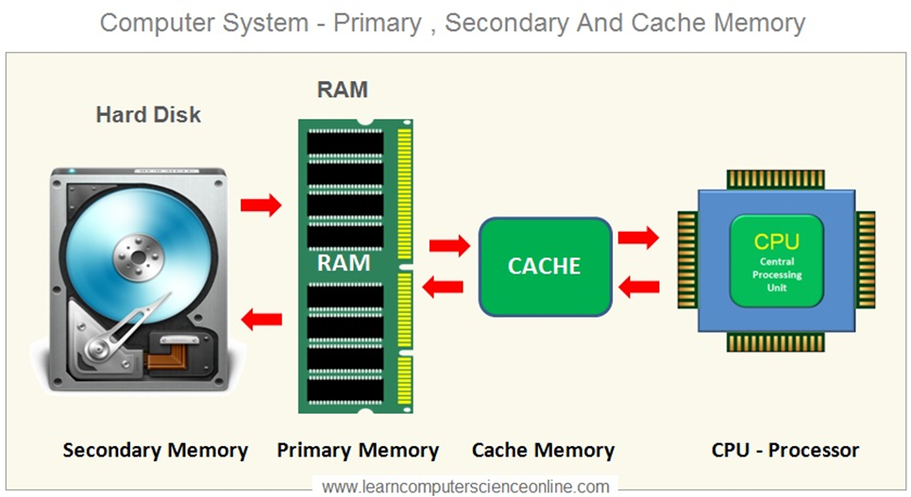

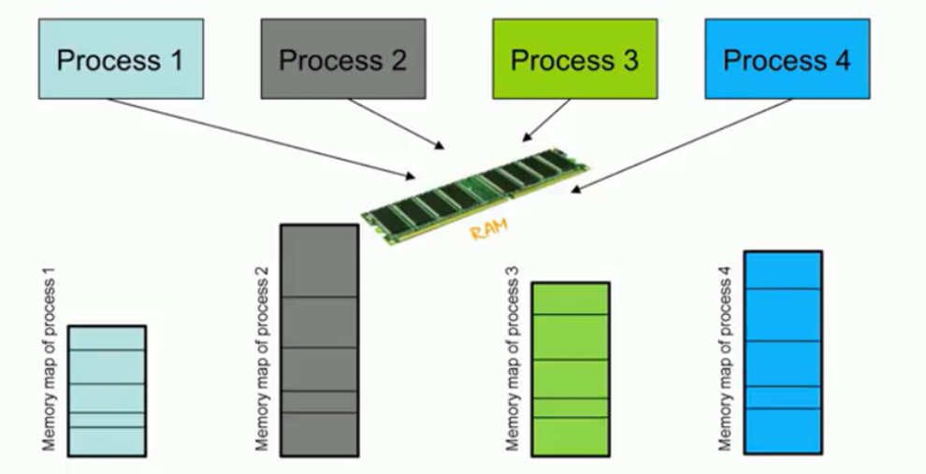

- Each process has a separate memory space(memory address).
- Separate per-process memory space protects the processes from each other and is fundamental to have multiple processes loaded in main memory for concurrent execution.
- To separate the memory spaces, we need the ability to determine the range of legal addresses that the process may access and to ensure that the process can access only these legal addresses.
- Protection of memory required to ensure correct operation.
- This protection can be provided by using two registers
  - Base register – holds the starting physical memory address of the process
  - Limit register – size of the range of process

For example , if the base register holds 300040 and limit register is 120900, then the program can legally access all addresses from 300040 through 420940(inclusive).

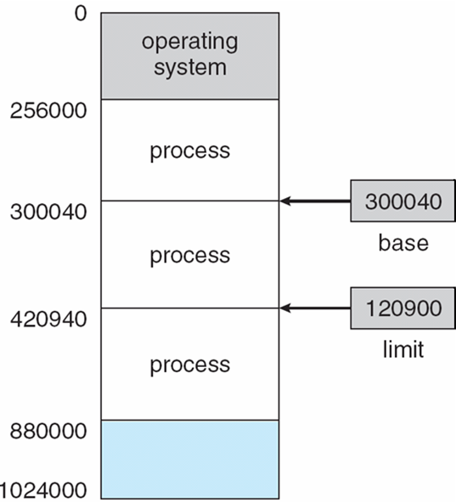

Fig4.1: Hardware address protection with base and limit registers

- Every memory access made by a user process is checked against these two registers, and if a memory access is attempted outside the valid range, then a fatal error is generated
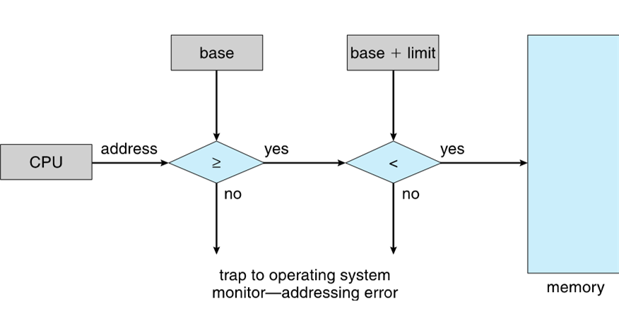
Fig.4.2 Hardware address protection with base and limit registers

4.2 Logical vs. Physical Address Space

- Logical address
  - A logical address is generated by CPU while a program is running.
  - Since a logical address does not physically exists it is also known as a virtual address
  - This address is used as a reference by the CPU to access the actual physical memory location.
  - There is a hardware device called Memory-Management Unit is used for mapping logical address to its corresponding physical address.
- The user program generates the logical address and believes that the program is running in this logical address space, but the program needs physical memory for its execution, therefore, the logical address must be mapped to the physical address by the MMU before the addresses are used.
- Physical address
- A physical address identifies the physical location of a specific data element in main memory
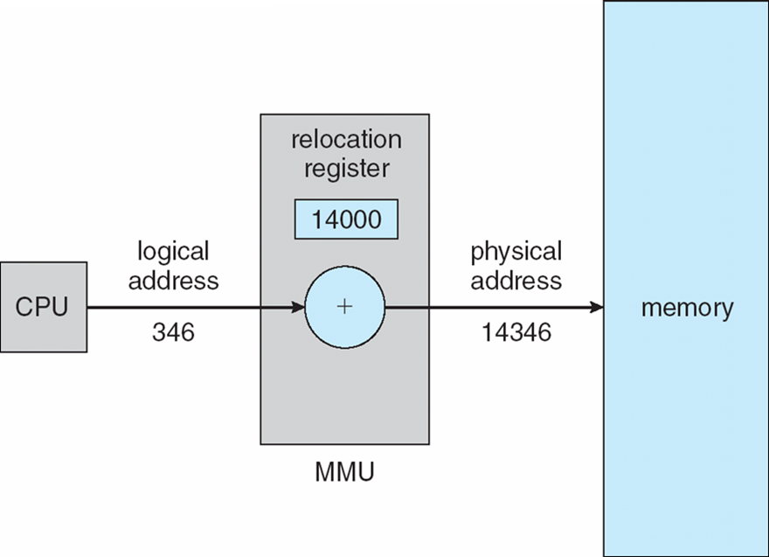
Logical and physical addresses are the same in compile-time and load-time address-binding schemes; logical (virtual) and physical addresses differ in execution-time address-binding scheme.

Address Binding
• Address binding of instructions and data to memory addresses can happen at three different stages.
o Compile time: If memory location known a priori, absolute code can be generated; must recompile code if starting location changes
o Load time: Must generate relocatable code if memory location is not known at compile time
o Execution time: Binding delayed until run time if the process can be moved during its execution from one memory segment to another. Need hardware support for address maps (e.g., base and limit registers)
Static vs Dynamic Loading
This is the choice to be made at the time of computer program is being developed. If you have to load your program statically then at the time of compilation, complete programming will be compiled and linked without leaving any external program or module dependency. The linker combines the object program with other necessary object modules into an absolute program, which also includes logical addresses.
If you are writing a Dynamically loaded program then your compiler will compile the program and for all the modules which you want to include dynamically, only references will be provided and rest of the work will be done at the time of execution.
A the time of loading, with static loading, the absolute program (and data) is loaded into memory in order for execution to start. If you are using dynamic loading, dynamic routines of the library are stored on a disk in relocatable form and are loaded into memory only when they are needed by the program.
Static vs Dynamic Linking
As explained above, when static linking is used, the linker combines all other modules needed by a program into a single executable program to avoid any runtime dependency. As explained above, when dynamic linking is used, it is not required to link actual module or library with the program, rather a reference to the dynamic module is provided at the time of compilation and linking.
Dynamic Link Libraries (DLL) in windows and Shared Objects in Unix are good examples of dynamic libraries.
4.3 Swapping

Swapping is a mechanism in which a process can be swapped temporarily out of main memory to secondary storage and make that memory available to other processes. At some later time, the system swaps back the process from the secondary storage to main memory.
- Eg:Round robin scheduling, Priority scheduling
- The system maintains a ready queue consisting of all processes who are ready to run.
- Whenever the cpu scheduler is decides to executes a process , it calls dispatcher.
- The dispatcher checks whether the next process in the queue is in memory or not.
- If it is not , and if there is no free space in the main memory, the dispatcher swaps out a process currently in memory and swaps in desired process.

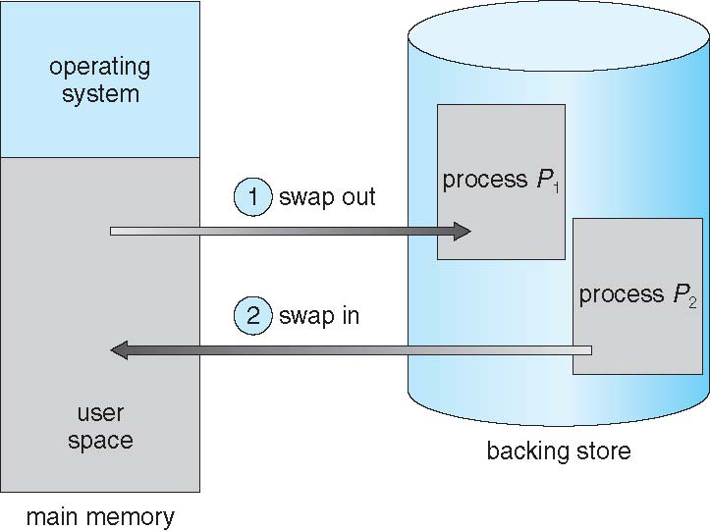

Roll out, roll in : swapping variant used for priority-based scheduling algorithms. If a higher priority process arrives and wants service, the memory manager can swap out the lower priority process so that it can load and execute lower priority process can be swapped back in and continued. This variant is some times called roll out, roll in.

4.4 Memory Allocation Techniques
- Contiguous Allocation
- Non-contiguous Allocation

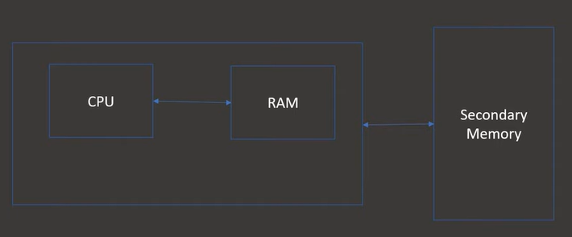

Contiguous Memory Allocation
- Contiguous memory allocation is a memory allocation method that allocates a single contiguous section of memory to a process

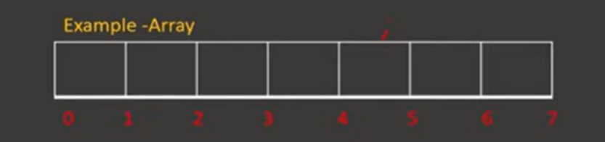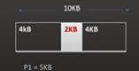

Advantage:
  - Less access time
Disadvantage
  - External fragmentation

Non-Contiguous Memory Allocation
- Allocates the memory space present in different locations to the process as per its requirement
- Contrary to contiguous allocation
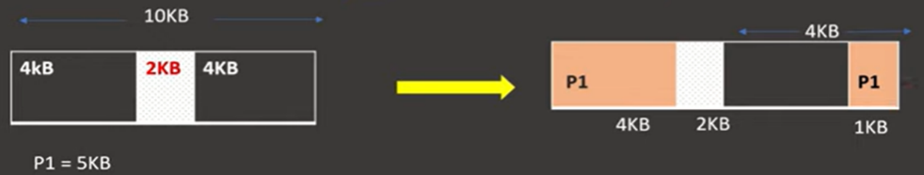

- Advantage
  - No External Fragmentation
- Disadvantage
  - More access time compared to contiguous allocation

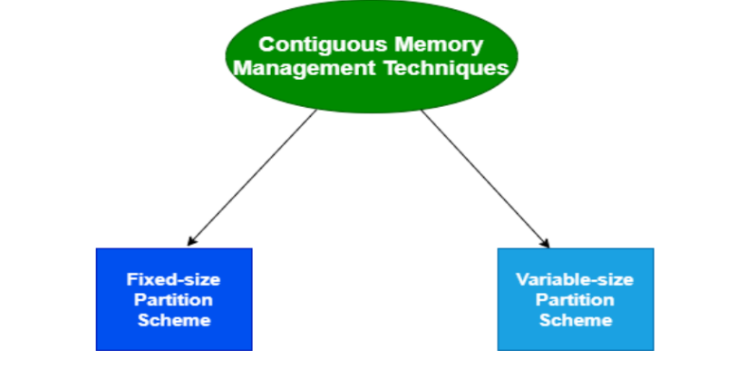
- Fixed Size Partition
- Also known as Static partitioning
- In this scheme, the system divides the memory into fixed-size partitions
- The partitions may or may not be the same size
- The size of each partition is fixed and it cannot be changed
In this partition scheme, each partition is allowed to contain exactly one process

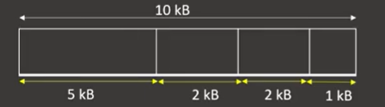

- Problem with fixed sized partition

- Internal Fragmentation

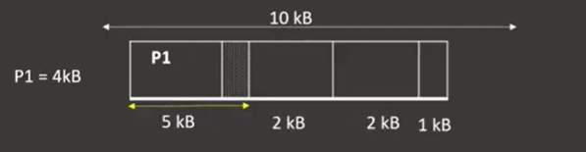

- Variable Partition
- Also called as Dynamic Partition
- It performs the allocation dynamically, there is no predefined partition.
- When a process arrives, a partition of size equal to the size of process is created and that partition is allocated to the process
- No internal fragmentation

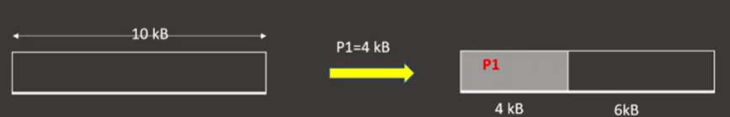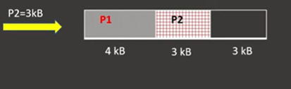

Fragmentation
- As processes are loaded and removed from memory, the free memory space is broken into little pieces. It happens after sometimes that processes can not be allocated to memory blocks considering their small size and memory blocks remains unused. This problem is known as Fragmentation.
- Fragmentation is of two types:
- Internal Fragmentation

Memory block assigned to process is bigger. Some portion of memory is left unused as it can not be used by another process. The internal fragmentation can be reduced by effectively assigning the smallest partition but large enough for the process.
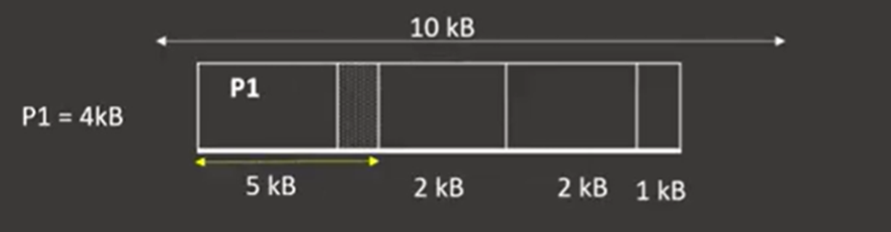

- External Fragmentation
Total memory space exists to satisfy a request, but it is not contiguous.

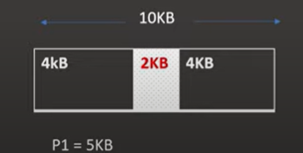

Partition Allocation Strategies/Dynamic Storage Allocation Problem
- Used to decide which hole is to be allocated to the arrived process.
- The free blocks of memory are known as holes
- Algorithms/Strategies:

- FIRST Fit
- BEST Fit
- WORST Fit

- First Fit
The first hole that is found to be large enough for a process to accommodate is selected

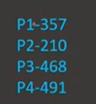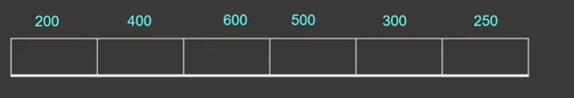
- Best Fit
The smallest hole that is large enough for the process to accommodate is selected from the list of free holes



- Worst Fit
The largest hole among the free holes is selected




Non-Contiguous Memory Allocation
- Allocates the memory space present in different locations to the process as per its requirement
- Contrary to contiguous allocation

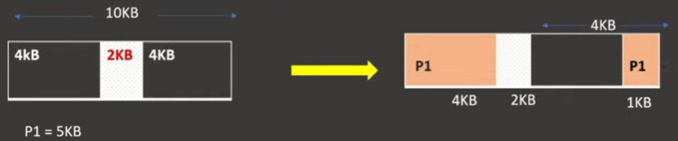

- Approaches
- Segmentation
- Paging

4.5 Segmentation

- Non-contiguous memory allocation method
- Memory-management scheme that supports user view of memory
- A program is a collection of segments

- A segment is a logical unit such as: main program, procedure, function, method etc
- Logical /address space is a collection of segments and each segment has a name and length

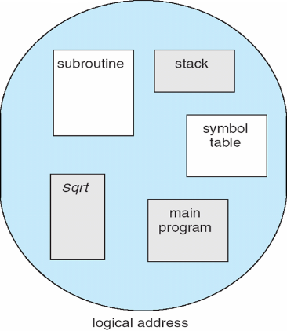

Logical View of Segmentation

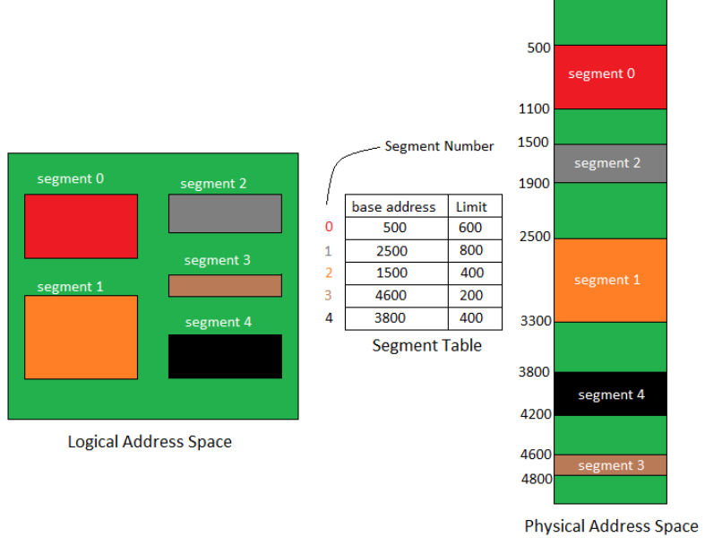

Segmentation Hardware/Architecture
- Logical address consists of a two tuple:
<segment-number, offset>
- Segment table – maps two-dimensional logical addresses into one dimensional physical address ;
- Each table entry has:
- base – contains the starting physical address where the segments reside in memory
- limit – specifies the length of the segment
- Segment-table base register (STBR) points to the segment table’s location in memory

Segmentation Hardware

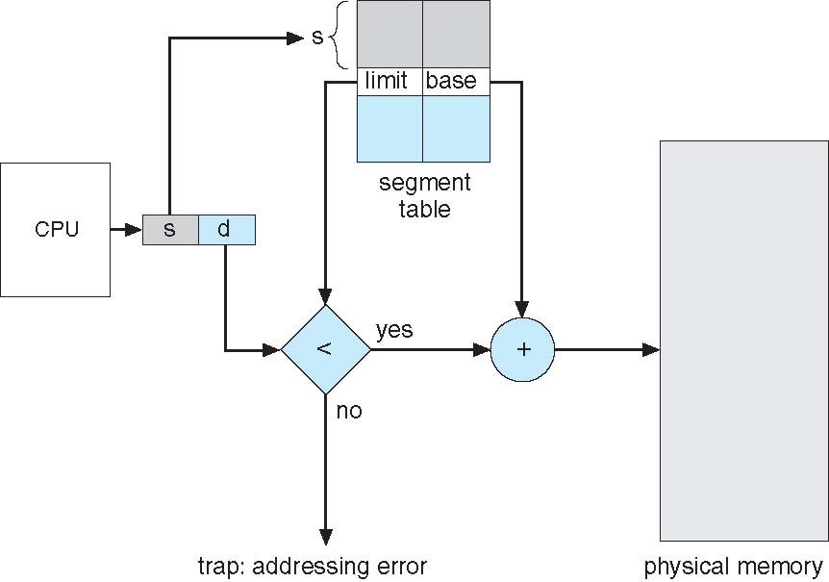

Example of segmentation
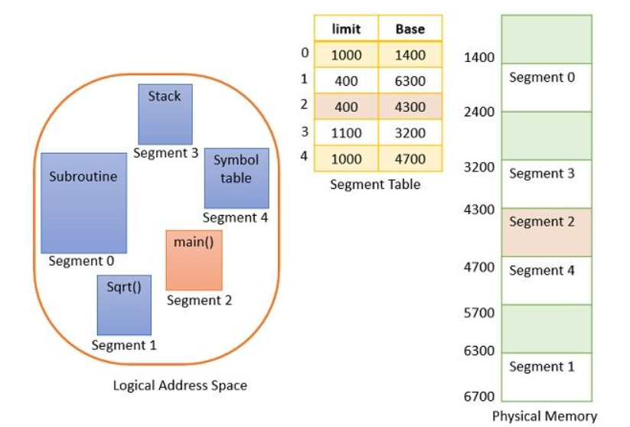
- Now suppose the CPU calls for segment number 2 which is 400 bytes long and it resides at 4300 memory location. The CPU wants to refer the 53rd byte of segment 2. So, here the input we get from CPU is segment number 2 and 53 as an offset.
- Now the offset is in between 0 and limit of the segment 2 i.e. 400. So, the condition got verified and the offset is being added to the base address of the segment 2 to reach the 53rd byte of the segment 2 in physical memory. In case you try to access the 453rd byte of segment 2 then it would result in a trap to the operating system as offset value 453 is greater than the limit of segment 2
- Advantages of Segmentation
- Offer protection within the segments
- You can achieve sharing by segments referencing multiple processes.
- Not offers internal fragmentation
- Segment tables use lesser memory than paging
- Disadvantages of Segmentation
- In segmentation method, processes are loaded/ removed from the main memory. Therefore, the free memory space is separated into small pieces which may create a problem of external fragmentation
- Costly memory management algorithm

4.6 Paging

Paging is a memory management scheme that permits the physical address space of a process to be non contiguous.Paging is a storage mechanism that allows OS to retrieve processes from the secondary storage into the main memory in the form of pages.That is when a process is executed , its pages are loaded into any available memory frames from their source. In the Paging method, the main memory is divided into small fixed-size blocks of physical memory, which is called frames.
The size of a frame should be kept the same as that of a page to have maximum utilization of the main memory and to avoid external fragmentation
Page size = frame size

Divide physical memory(main memory) into fixed-sized blocks called frames.
Divide the logical memory(secondary memory) into blocks of same size called pages.
The size of a page is defined by hardware. Page table is used to keep track relation between page of a process to a frame in physical memory. The page size is typically power of 2, varying between 512 bytes and 16 MB per page, depending on the computer architecture.

The selection of a power of 2 as a page size makes the translation of a logical address into a page number and page offset particularly easy. If the size of logical address is 2m , and a page size is 2n addressing units, then the high order m-n bits of a logical address designate the page number, and the n low order bits designate the page offset.

For example, if the main memory size is of total 16 KB and its Frame size is 1 KB. Here, the main memory will be divided into the collection of 16 frames of 1 KB each.

There are 4 separate processes in the system that is A1, A2, A3, and A4 of 4 KB each. Here, all the processes are divided into pages of 1 KB each so that operating system can store one page in one frame.At the beginning of the process, all the frames remain empty so that all the pages of the processes will get stored in a contiguous way.

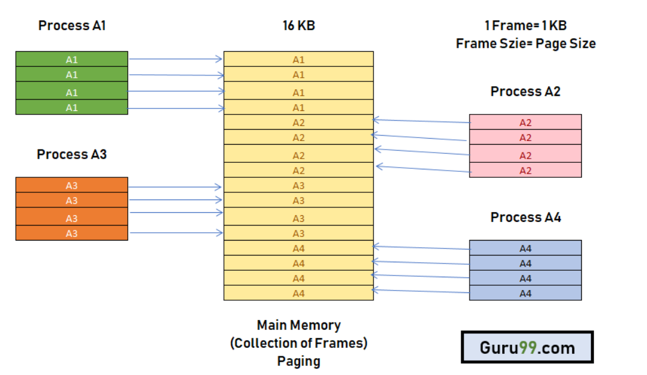

Paging Model of Logical and Physical Memory

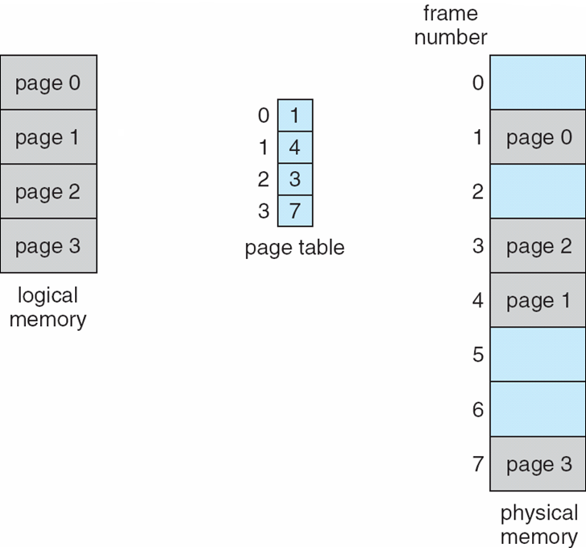

Paging Hardware

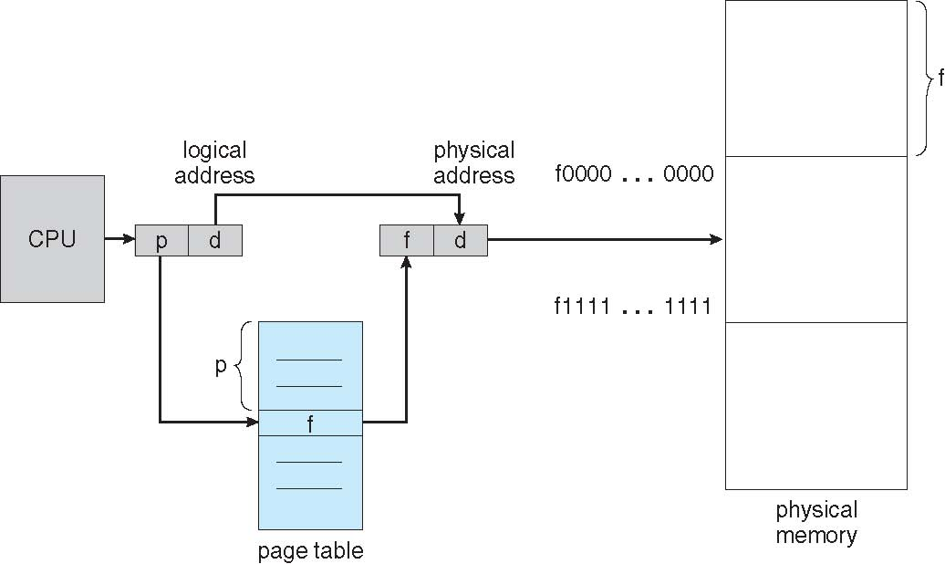

- Address generated by CPU is divided into:
- Page number (p) – used as an index into a page table
- Page offset (d) – d is the displacement within the page.
The base address in the page table combined with the page offset to define physical memory address that is sent to the memory unit.
Physical address = frame number * page size + offset
In the example

- Logical address 0 (page 0 ,offset 0) maps to physical address 20 [(5*4)+0]
- Logical address 3(page 0,offset 3) maps to physical address 23 [(5*4)+3]
- Logical address 4(page 1,offset 0) maps to physical address 23 [(5*4)+3]
- Logical address 13 maps to physical address 9

EXAMPLE

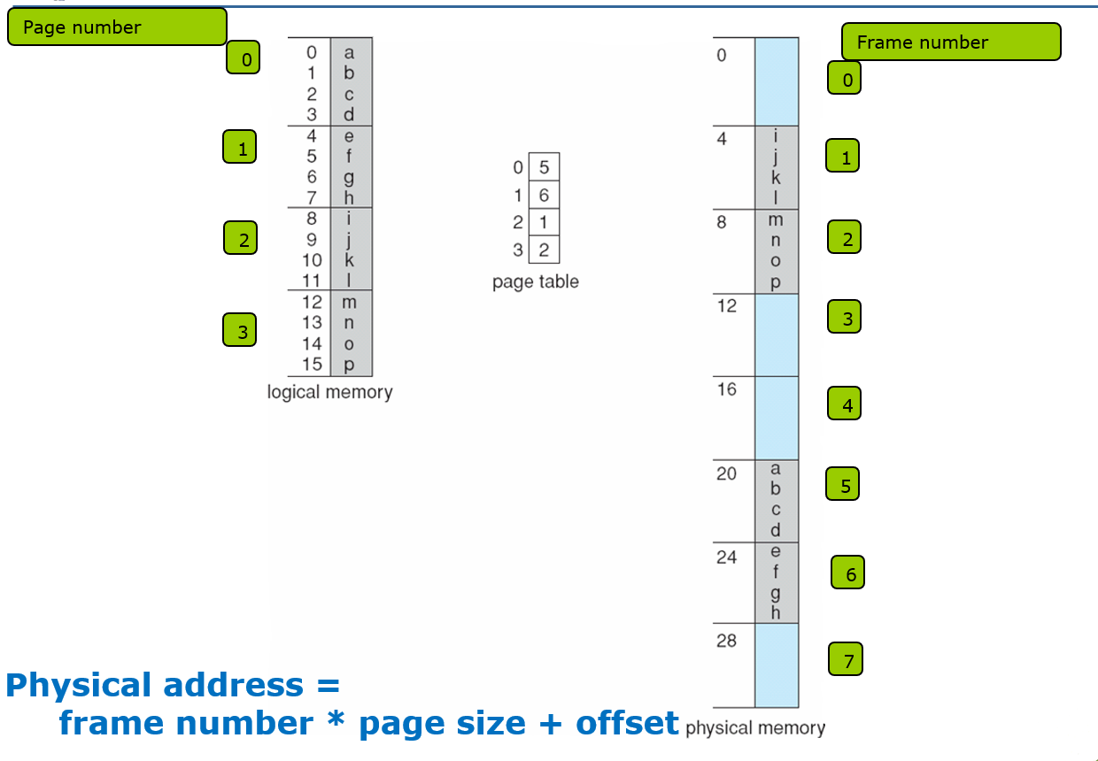

Advantages of Paging

Here, are advantages of using Paging method:
- Easy to use memory management algorithm
- No need for external Fragmentation
- Swapping is easy between equal-sized pages and page frames.

Disadvantages of Paging
- May cause Internal fragmentation
- Page tables consume additional memory.
- Multi-level paging may lead to memory reference overhead.

TLB – Translation Lookaside Buffer

  - Special cache contains page table entries that have been most recently used.
  - Small and fast lookup hardware cache with high speed

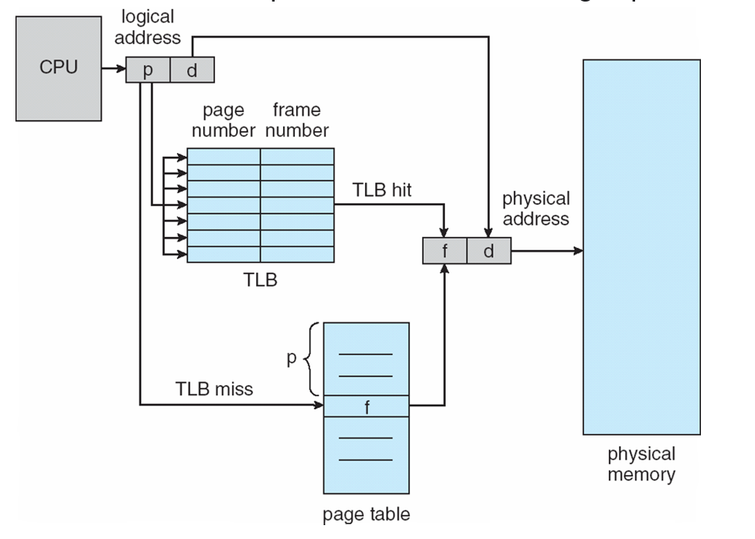
Steps in TLB hit:
- CPU generates logical address.
- It is checked in TLB (present).
- Corresponding frame number is retrieved, combining page number and offset tells where in the main memory page lies and access the main memory.

Steps in TLB miss:
- CPU generates logical address.
- It is checked in TLB (not present).
- Now the page number is matched to page table residing in main memory
- Corresponding frame number is retrieved, combining page number and offset tells where in the main memory page lies.
- The TLB is updated with new PTE (if space is not there, one of the replacement technique either FIFO, LRU, Optimal ).
Protection

-With each page table entry a valid–invalid bit is associated
(v ⇒ in-memory / memory resident,
i ⇒ not-in-memory)
-Initially valid–invalid bit is set to i on all entries
-Example of a page table snapshot:

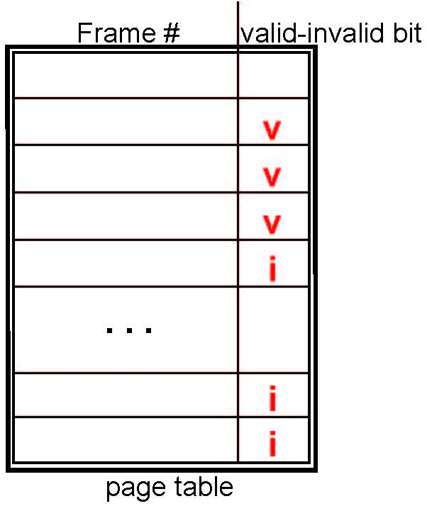
-During MMU address translation, if valid–invalid bit in page table entry is i ⇒ page fault
Structure of a Page Table

1.Hierarchical Paging
2.Hashed Page Table
3.Inverted Page Table

Effective Access Time
The percentage of times that a particular page number is found in the TLB is called the hit ratio.

An 80 percent hit ratio , for eg, means that we find the desired page number in the TLB 80% of the time.

Effective access time(EAT) = h*m + (1-h)*2m
where, h = hit ratio of TLB
m = Memory access time

If hit ratio is 80%, memory access time is 100 nanosecond,
EAT = 0.80 x 100 + 0.20 x 200 = 120ns

If hit ratio is 99%, memory access time is 100 nanosecond,
EAT = 0.99 x 100 + 0.01 x 200 = 101ns

4.7 Virtual Memory

-Virtual Memory is a storage scheme that provides user an illusion of having a very big main memory.
-Virtual memory is a technique that allows the execution of processes that are not completely in memory.one main advantage of this scheme is that programs can be larger than physical memory.
-This is done by treating a part of secondary memory as the main memory.
-A computer can address more memory than the amount physically installed on the system. This extra memory is actually called virtual memory .

Advantages of Virtual memory – separation of user logical memory from physical memory
  - Only part of the program needs to be in memory for execution
  - Logical address space can therefore be much larger than physical address space
  - Allows address spaces to be shared by several processes
  - Allows for more efficient process creation
  - More programs running concurrently
  - It is most commonly implemented by demand paging.

Virtual Memory That is Larger Than Physical Memory

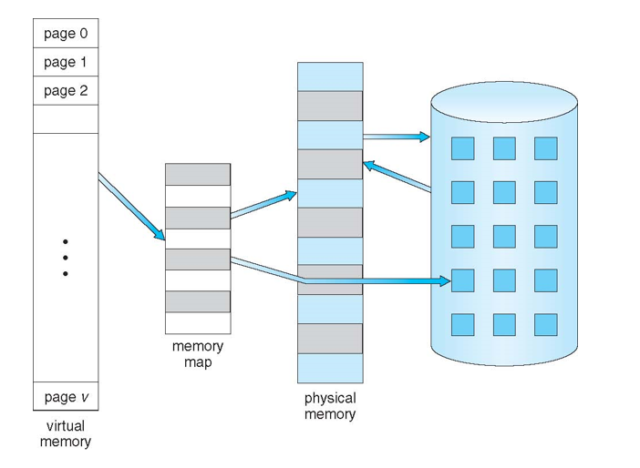

Virtual Address Space

Virtual address space of a process refers to the logical(virtual) view of how process is stored in memory
  - Usually start at address 0, contiguous addresses until end of space
  - Meanwhile, physical memory organized in page frames
  - MMU must map logical to physical
  - Enables sparse address spaces with holes left for growth, dynamically linked libraries, etc

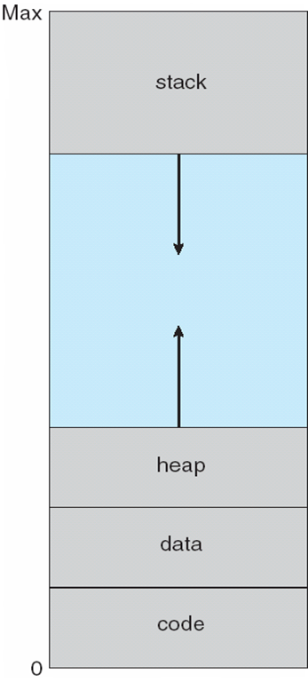

Shared Pages
- Advantages of paging is the sharing of common codes(read only program)
- Sharing pages is especially advantageous in time-sharing systems. A reentrant program (non-self-modifying code = read only) never changes during execution. So, more than one process can execute the same code at the same time.
- Example: Shared code : One copy of read-only code shared among processes (i.e., text editors, compilers, window systems)
- Store shared page in a single page frame and Map it to logical address spaces of processes by inserting appropriate entries in their page tables that all point to the shared page frame.
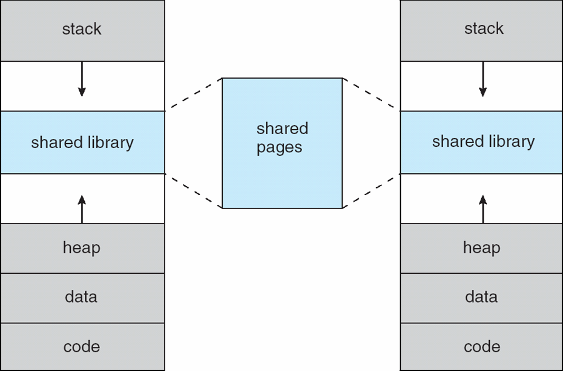

4.8 Demand Paging

A demand paging system is similar to the paging system with swapping feature. When we want to execute a process we swap it into the memory. A swapper manipulates entire process where as a pager is concerned with the individual pages of a process. The demand paging concept is using pager rather than swapper. When a process is to be swapped in, the pager guesses which pages will be used before the process is swapped out again. Instead of swapping in a whole process, the pager brings only those necessary pages into memory.
-Lazy swapper – never swaps a page into memory unless page will be needed.
-In the case of demand paging we use the term pager instead of swapper because pager is concerned with the individual pages of a process while swapper manipulates the entire process.

The transfer of a paged memory to contiguous disk space is shown in below figure:
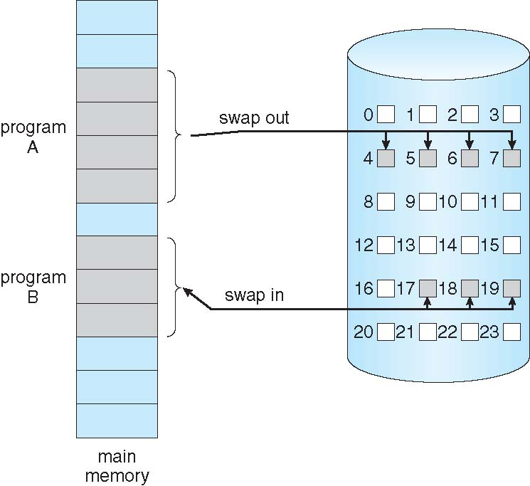

Thus it avoids reading into memory pages that will not used any way decreasing the swap time and the amount of physical memory needed. In this technique we need some hardware support to distinct between the pages that are in memory and those that are on the disk. A valid and invalid bit is used for this purpose. When this bit is set to valid it indicates that the associate page is in memory. If the bit is set to invalid it indicates that the page is either not valid or is valid but currently not in the disk.

Valid-Invalid Bit

-With each page table entry a valid–invalid bit is associated
(v ⇒ in-memory / memory resident, i ⇒ not-in-memory)
-Initially valid–invalid bit is set to i on all entries
Example of a page table snapshot:

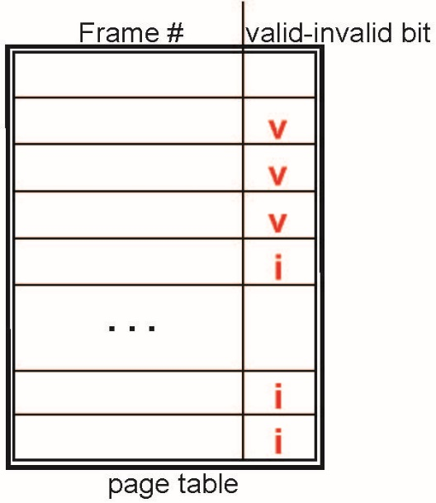

-During MMU address translation, if valid–invalid bit in page table entry is i ⇒ page fault

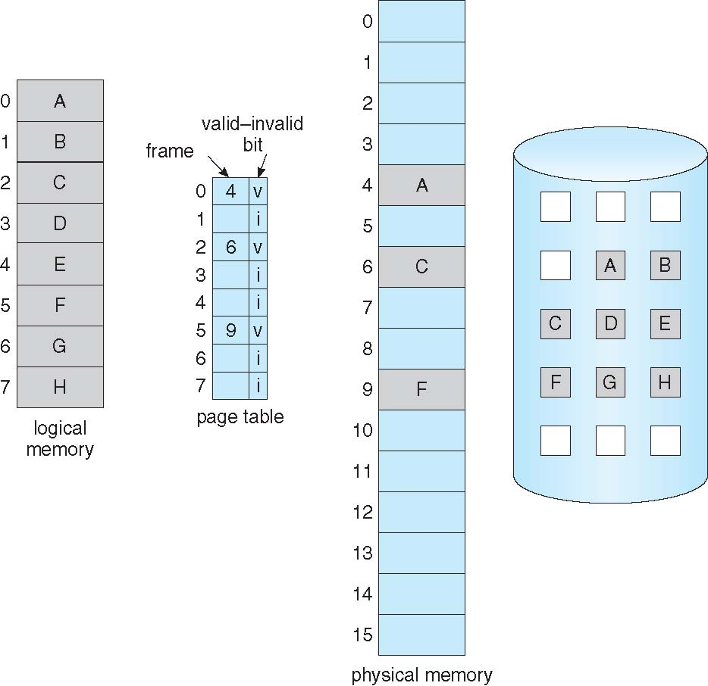

Marking a page invalid will have no effect if the process never attempts to access that page. So while a process executes and access pages that are memory resident, execution proceeds normally. Access to a page marked invalid causes a page fault trap. It is the result of the OS’s failure to bring the desired page into memory.

Steps in Handling a Page Fault

- A page fault occurs when a program attempts to access data or code that is in its address space, but is not currently located in the system RAM.
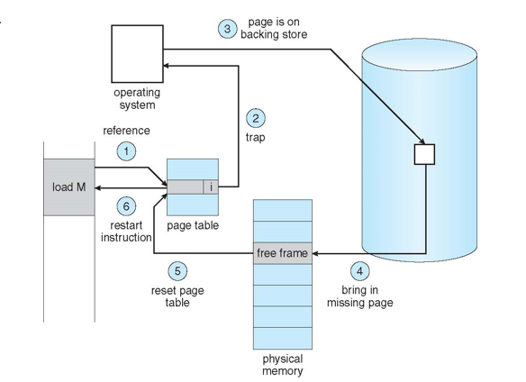

Procedure for handling page fault
If a process refers to a page that is not in physical memory then
• We check an internal table (page table) for this process to determine whether the reference was valid or invalid.
• If the reference was invalid, we terminate the process, if it was valid but not yet brought in, we have to bring that from main memory
• Now we find a free frame in memory.
• Then we read the desired page into the newly allocated frame.
• When the disk read is complete, we modify the internal table to indicate that the page is now in memory. • We restart the instruction that was interrupted by the illegal address trap.
Now the process can access the page as if it had always been in memory.
Effective Access Time (EAT)

EAT = (1 – p) x memory access + p (page fault overhead+swap page out + swap page in )

Demand Paging Example

Memory access time = 200 nanoseconds
Average page-fault service time = 8 milliseconds
EAT = (1 – p) x 200 + p (8 milliseconds)
= (1 – p x 200 + p x 8,000,000
= 200 + p x 7,999,800
If one access out of 1,000 causes a page fault, then
EAT = 8.2 microseconds.
This is a slowdown by a factor of 40!!
If want performance degradation < 10 percent
220 > 200 + 7,999,800 x p
20 > 7,999,800 x p
p < .0000025
< one page fault in every 400,000 memory accesses

4.9 Page Replacement

Basic Page Replacement

- Find the location of the desired page on disk
- Find a free frame:
- If there is a free frame, use it
- If there is no free frame, use a page replacement algorithm to
select a victim frame
- Write victim frame to disk if dirty/updated
- Bring the desired page into the (newly) free frame; update the page and frame tables
- Continue the process by restarting the instruction that caused the trap

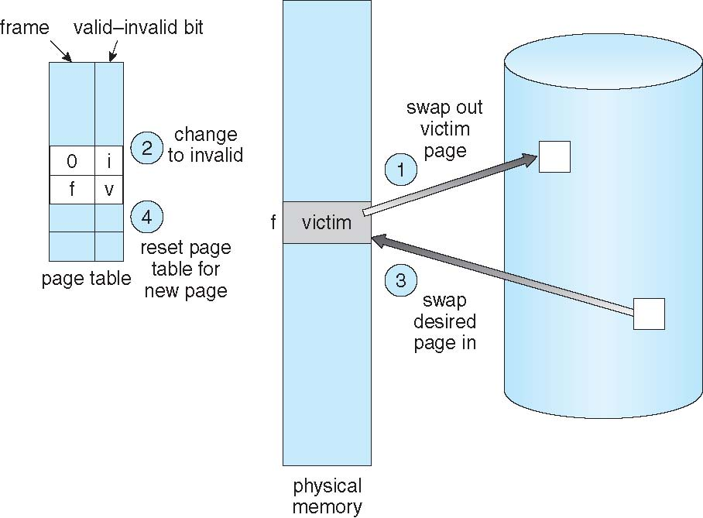

Page Replacement Algorithms

  - Page replacement algorithms help to decide which page must be swapped out from the main memory to create a room for the incoming page.
  - Algorithms:
  - FIFO Page Replacement Algorithm
  - LRU Page Replacement Algorithm
  - Optimal Page Replacement Algorithm

- A good page replacement algorithm is one that minimizes the number of page faults

- FIFO Page Replacement Algorithm

- Works on the principle of “First in First out“.
- It replaces the oldest page that has been present in the main memory for the longest time.
- Simplest Algorithm
- In this algorithm, the operating system keeps track of all pages in the memory in a queue, the oldest page is in the front of the queue.
- When a page needs to be replaced page in the front of the queue is selected for removal.

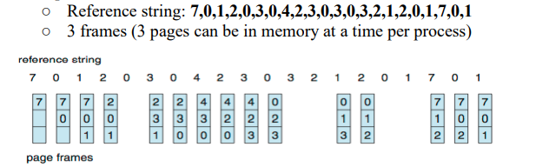

Belady’s anomaly
- Bélády’s anomaly is the name given to the phenomenon where increasing the number of page frames results in an increase in the number of page faults for a given memory access pattern.
- Beladys anomaly can occur in FIFO page replacement algorithm.
- For example, if we consider reference string 3, 2, 1, 0, 3, 2, 4, 3, 2, 1, 0, 4 and 3 slots, we get 9 total page faults, but if we increase slots to 4, we get 10 page faults.
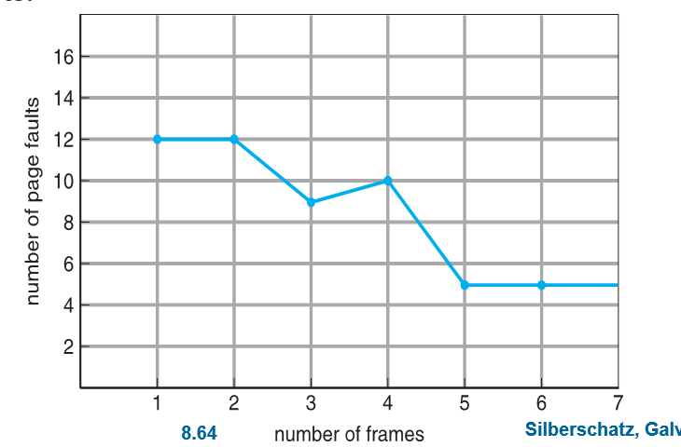

Example:2
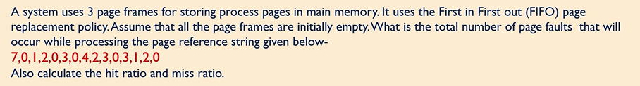

Example 3:
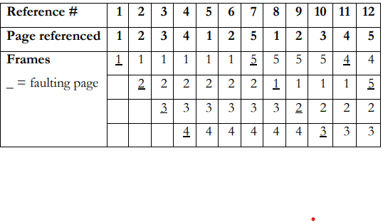
Analysis: 12 page references, 10 page faults, 6 page replacements.
Page faults per number of frames = 10/4 = 2.5
- LRU Page Replacement Algorithm

- Least Recently Used
- In this algorithm page will be replaced which is least recently used
- That is, it replaces the page that has not been referred by the CPU for the longest time

Consider the page reference string 7, 0, 1, 2, 0, 3, 0, 4, 2, 3, 0, 3, 2 with 4 page frames. Find number of page faults.

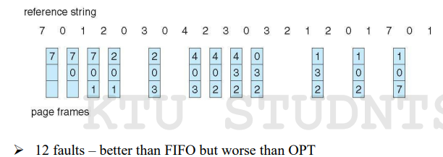

Example 2: 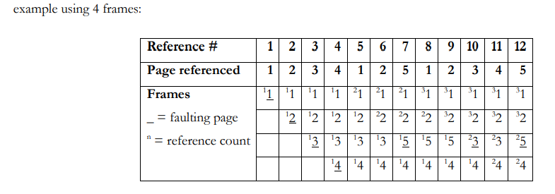
Analysis: 12 page references, 7 page faults, 3 page replacements. Page faults per number of frames = 7/4 = 1.75

- Optimal Page Replacement Algorithm

- In this algorithm, pages are replaced which would not be used for the longest duration of time in the future.
- Although it can not be practically implementable but it can be used as a benchmark. Other algorithms are compared to this in terms of optimality.
-It has the lowest page fault rate of all algorithms and will never suffer from Belady’s Anomaly

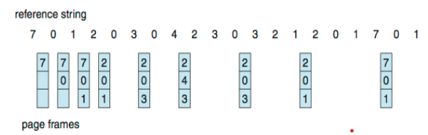

Example 2: 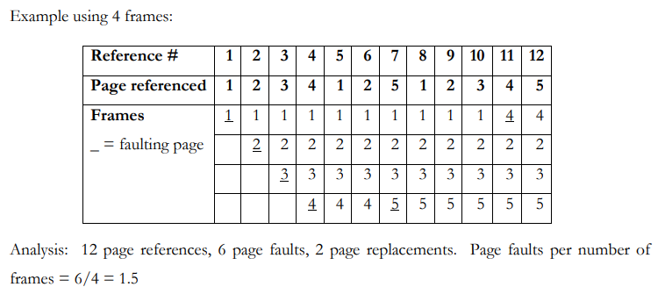

4.10 Thrashing

-In case, if the page fault and swapping happens very frequently at a higher rate, then the operating system has to spend more time swapping these pages.
-This state in the operating system is termed thrashing.
-Because of thrashing the CPU utilization is going to be reduced.

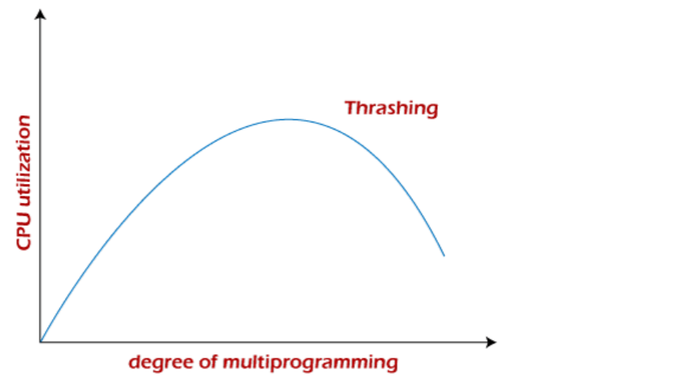
Previous university Questions
- Explain the concept of paging.
- Differentiate logical address and physical address with an example.
- With the help of a diagram, explain logical address to physical address translation in paging. Illustrate with an example.
- Describe contiguous memory allocation.
- Given six memory partitions of 300 KB, 600 KB, 350 KB, 200 KB, 750 KB, and 125 KB (in order), how would the first-fit, best-fit, and worst-fit algorithms place processes of size 115 KB, 500 KB, 358 KB, 200 KB, and 375 KB (in order)? Rank the algorithms in terms of how efficiently they use memory.
- Explain Optimal page replacement and LRU algorithms for page replacement
- Find the number of page faults for the following page reference string with 3 page frames for Optimal page replacement and LRU algorithms. 2 3 4 2 1 3 7 5 4 3
- With a diagram, explain how paging is done with TLB
- How is protection done in paging systems?
- Differentiate internal fragmentation and external fragmentation.
- How is swapping done? Explain with the help of a diagram.
- What do you mean by thrashing?
- Discuss the following terms: (i) Roll out,roll in (ii) External fragmentation (iii) 50-percent rule
- How is segmentation different from paging?
- Discuss the different aspects of contiguous memory allocation?
- Discuss the steps in handling a page fault?
- Consider the following page reference string: 7,2,3,1,2,5,3,4,6,7,7,1,0,5,4,6,2,3,0,1.
  - Assuming demand paging with three frames, how many page faults would occur for the following page replacement algorithms. i) LRU replacement ii) FIFO replacement iii) Optimal replacement
- What is the function of a translation look-aside buffer (TLB)
- Why are page sizes always powers of 2?
- Given memory partitions of 100 KB, 500 KB, 200 KB, 300 KB, and 600 KB. How would each of the First fit Best-Fit and Worst-Fit algorithms place processes of 212 KB, 417 KB, 112 KB, and 426 KB?
- With the help of a diagram explain the steps involved in handling a page fault.
- Compare the memory organization schemes of contiguous memory allocation, pure segmentation, and pure paging with respect to the following issues: i. External fragmentation ii. Internal fragmentation iii. Ability to share code across processes
- Given six memory partitions of 100KB,500 KB,200 KB,300 KB,600 KB (in order),how would the first-fit, best-fit and worst-fit algorithms place processes of size 212KB,417 KB,112 KB,426KB(in order). Rank the algorithms in terms of how efficiently they use memory.
- Consider a logical address space of 64 pages of 1024 words each, mapped onto a physical memory of 64 frames. a. How many bits are required in the logical address? b. How many bits are required in the physical address?
- Consider the following segment table:
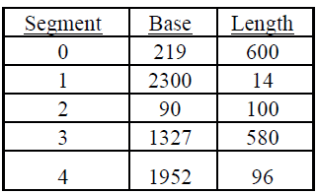
What are the physical addresses for the following logical addresses?
i.) 0,430 ii.) 1,10 iii.) 2,500 iv.) 3,400 v.) 4,112
- What is dynamic storage-allocation problem with respect to contiguous memory allocation? Discuss the three strategies that act as a common solution to this problem.
- What is demand paging? What are its advantages?
- With the help of an example explain the paging concept.
- Does paging suffer from fragmentation? Explain.
- Consider the reference string: 8 4 6 4 3 5 8 4 3 2 3 5 8. Assuming demand paging with four frames, how many page faults would occur for:- i) FIFO replacement algorithm ii) Optimal replacement algorithm
- Consider the following page reference string : 7, 0, 1, 2, 0, 3, 0, 4, 2, 3, 0, 3, 2, 1, 2, 0 Indicate page faults and calculate total number of page faults for FIFO algorithm, assuming that number of frames as three and four. Remember initially all the frames are empty. Check whether Belady’s anomaly happens.
- Does paging suffer from fragmentation? Justify your answer.
- Consider a simple paging system with 8KB page size and a page table with each entry of size 4 bytes. Answer the following questions. (i) How many bits are used for representing the page offset value? (ii) What is the size of the physical memory (in bytes) that can be addressed? (iii) Calculate the amount of internal fragmentation for a process of size 205KB. (iv) Is it possible to load a process of size 98KB if there are 12 free frames. Justify your answer. (v) How many frames are required for storing a process of size 331KB?
- Explain the terms (i) Dynamic Loading (ii) Dynamic Linking
- Consider a fixed partitioned memory management scheme with fixed partitions are 150K, 300K, 550K, 400K, 250K and 200K (in order). Five processes are ready for execution each with memory requirement as P1(240K), P2(120K), P3(380K), P4(300K) and P5(350K). Write the allocation in each of the following cases and calculate the internal fragmentation and external fragmentation (if any) in each case. (i) First Fit (ii) Best Fit
2019 university Questions
17 a) Explain with the help of supporting diagram, how translation look-aside buffer (TLB) improves the performance of a paging system. 8 b) With a diagram write the steps involved in handling a page fault.
18 a) Consider the page reference string 1,2,3,4,2,1,5,6,2,1,2,3,7,6,3,2,1,2,3,6. For a system with 3 frames compute the number of page faults for the following page replacement methods: (i) FCFS (ii) Optimal (ii) LRU.

19 b) Consider the following segment table:
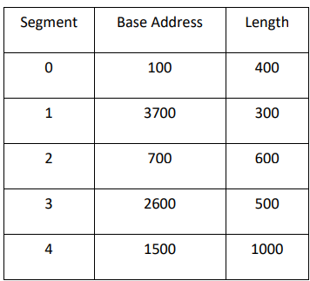
What are the physical addresses for the following logical addresses? (i) 4, 350 (ii) 2, 100 (iii) 3, 70 (iv) 0, 25 (v) 1, 130

